**DAILY ONLINE ACTIVITIES SUMMARY**

|  |  |  |  |  |  |  |  |  |
| --- | --- | --- | --- | --- | --- | --- | --- | --- |
| **Date:** | **16-07-2020** | | | | | **Name:** | **Rani M.D** | |
| **Sem & Sec** | **VI Sem B** | | | | | **USN:** | **4AL17CS075** | |
| **Pre-placement Training Summary** | | | | | | | | |
| **Subject** | |  | | | | | | |
| **Max. Marks** | | **-** | | **Score** | | | **-** | |
| **Online Certification Summary** | | | | | | | | |
| **Course** | Block chain | | | | | | | |
| **Certificate Provider** | | | **Coursera** | | **Duration** | | | **4 week** |
| **Coding Challenges** | | | | | | | | |
| **Problem Statement:**  **Python Program to Check if binary representation is palindrome** | | | | | | | | |
| **Status:Completed** | | | | | | | | |
| **Uploaded the report in Github** | | | | | **Yes** | | | |
| **If yes Repository name** | | | | | Daily Status | | | |
| **Uploaded the report in slack** | | | | | **Yes** | | | |

Online Certification Details:

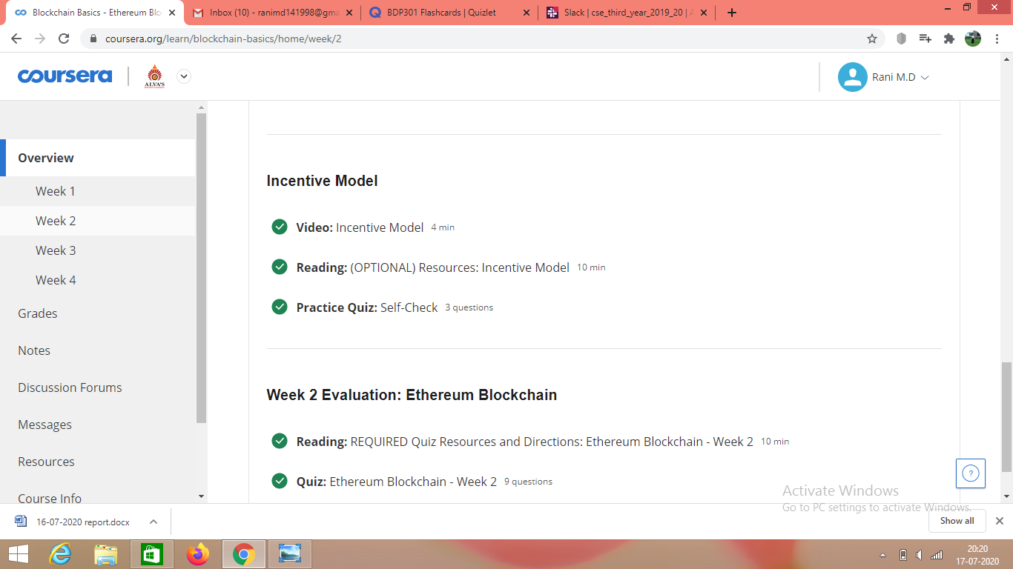

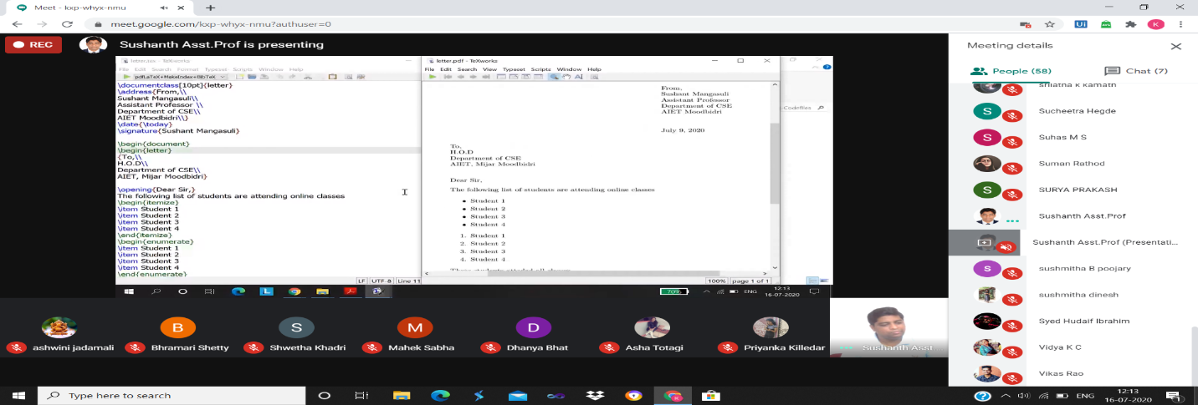

Coding Challenges Details:

**Python Program to Check if binary representation is palindrome**

